Victorian Roses Frame by BeetleCraft
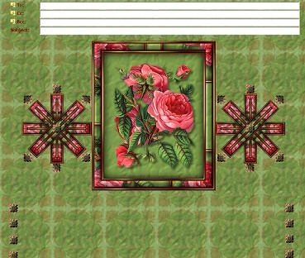
This tutorial is written for Paint Shop Pro 8.
SUPPLIES:
Any floral tube should work.
Plugins needed:
Simple
Greg's Factory Output Vol. II

FRAME:
1. Resize tube to no larger than 380 on longest side. Shift/D and set copy aside.
2. Select a light color and a dark color from your tube.
3. Layers/New Raster Layer
4. Flood fill with light color
5. Effects/Texture - use the settings you see below.
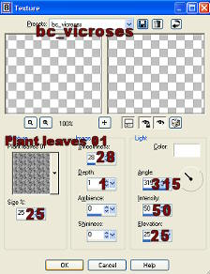
6. Layers/Arrange/Send to Bottom.
7. Click on tube layer which should now be the top layer - Selections/Select All - Selections/Float and it should put marching ants around the tube.
8. Selections/Modify/Contract by 5
9. Selections/Modify/Feather by 5
10. Selections/Invert and then hit the delete key (you may have to adjust the contract and feather depending on the tube.)
11. Selections/Invert
12. Effects/3D Effects/Drop Shadow using settings below.
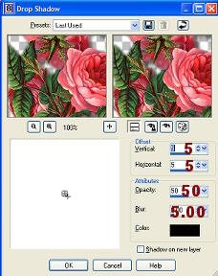
13. Merge/Merge All Flatten
14. Selections/Select All
15. Effects/3D Effects/CutOut using the settings below.
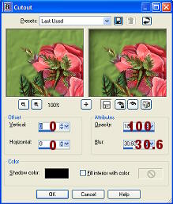
16. Image/Add borders - 2 - symmetric checked - dark color
17. Image/Add borders - 4 - symmetric checked - light color
18. Selections/Select All - Selections/Modify/Contract 4 - Selections/Invert
19. Effects/Plugins/Greg's Factory Output Vol. II/Pool Shadow/default settings
20. Effects/3D Effects/Inner Bevel using the settings below.
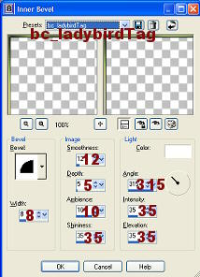
21. Image/Add borders - 2 - symmetric checked - dark color
22. Image/Add borders - 20 - symmetric checked - light color
23. Selections/Select All - Selections/Modify/Contract 20 - Selections/Invert
24. Effects/Plugins/Simple/Blintz
25. Effects/Texture - (same as step #5)
26. Effects/3D Effects/Inner Bevel - (same settings as step #20)
27. Image/Add borders - 2 - symmetric checked - dark color
28. Image/Add borders - 4 - symmetric checked - light color
29. Selections/Select All - Selections/Modify/Contract 4 - Selections/Invert
30. Effects/Plugins/Greg's Factory Output Vol. II/Pool Shadow/default settings
31. Effects/3D Effects/Inner Bevel - same settings as step #20
32. Image/Add borders - 2 - symmetric checked - dark color
33. Add watermark if you want then save as .jpg.
34. Image/Image Information and make note of the height of this framed image - see example below.
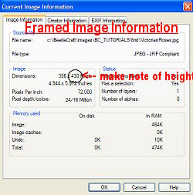
35. Set aside.

BACKGROUND:
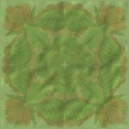
1. New Image - transparent - 150 x 150
2. Selections/Select All
3. Go to the copy of the tube you have setting aside. Edit/Copy
4. Back to your new transparent image and Edit/Paste/Paste Into Selection - Selections/Select none.
5. Effects/Plugins/Simple/Pizza Slice Mirror
6. Layers/New Raster Layer and flood fill with your light color
7. Lower opacity to about 80
8. Layers/Merge/All Flatten
9. Effects/Texture - use the settings below.
10. Save as .jpg

FLOWER ICON:
1. New image - transparent - 25 x 25
2. Selections/Select All
3. Go again to the tube you have setting aside, Edit/Copy
4. Back to your new image and Edit/Paste/Paste Into Selection - Selections/Select None.
5. Effects/Plugins/Simple/Pizza Slice Mirror
6. Effects/3D Effects/Inner Bevel
7. Save as transparent .gif - Set aside

SIDEBAR: Part A
1. Selections Tool/Rectangle - Select bottom of framed image from left side to right side and up till the first set of borders meets the image. See example below.
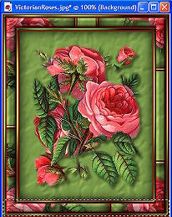
2. Edit/Copy - Edit/Paste/Paste As New Image.
3. Image/Canvas Size - keep the same width but double the height .. make sure you hit the
down arrow toggle. See example below.
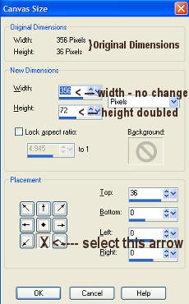
4. Layers/Duplicate
5. Image/Flip
6. Layers/Merge/Merge All Fatten
7. Resize : 75% Bicubic - all layers unchecked - do this twice - See example below.
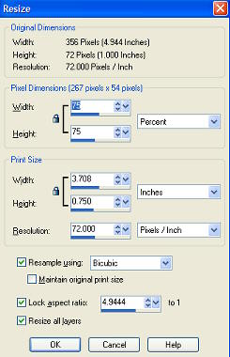
8. Edit/Copy
9. Image/Image Information and make note of the width of this bar - see example below.
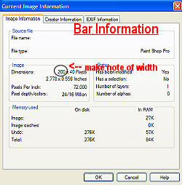
10. Set aside.

SIDEBAR: Part B
1. New image - transparent - make the width the same as the bar width you noted (see #9 of SIDEBAR:Part B) and make the height the same as the framed image height you noted. (see #34 of FRAME: above.) See example below.
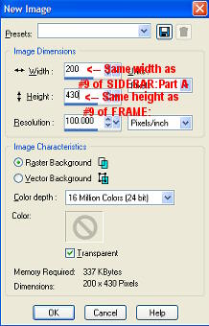
2. Edit/Paste/Paste As New Layer - 2 times (this should paste your sidebar you just made two different layers) or you can Ctrl+L two times.
3. Highlight layer #3 - Image/Rotate/Free Rotate - check right - 90 degrees .. all layers unchecked .. Rotate single layer around canvas center checked. See example below.
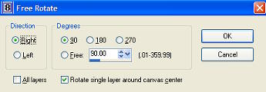
4. Edit/Paste/Paste As New Layer - this should paste your bar again on a new layer.
5. Image/Rotate/Free Rotate - check right - 45 degrees .. all layers unchecked .. Rotate single layer around canvas center checked. See example below.
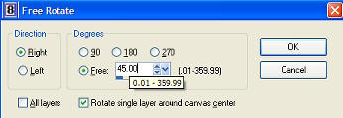
6. Layers/Duplicate - Image/Mirror
7. Go to your icon image you created - Edit/Copy -
back to the bar you're working on
8. Edit/Paste/Paste As New Layer - it puts the icon directly in the center - See example.
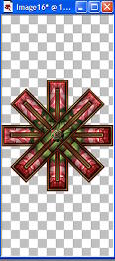
9. Layers/Duplicate - this will make a second icon layer directly on top of the first icon. Copy of Raster 5 should be the top layer.
10. Select the move tool - take the top icon and move it to the top of the verticle bar, with just a slight bit of
space between showing. See example.
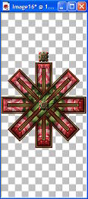
11. Layers/Duplicate - Image/Flip - this will add another icon layer and will flip it to the bottom of the verticle bar. See example.
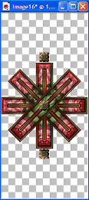
12. Layers/Duplicate (Copy (3) of Raster 5 should be the top layer) - Select the Move tool and move icon so the corner of it is almost touching the diagonal icon to the
left of the bottom one. See example.
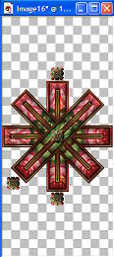
13. Layers/Duplicate -Image/Flip
14. Layers/Duplicate - Image/Mirror
15. Layers/Duplicate - Image/Flip - your bar should now look like example below.
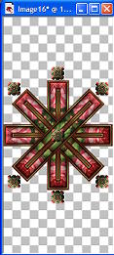
16. Layers/Merge/Merge Visible
17. Save As transparent .gif

Put together in Letter Creator as you'd like or use my example at the top on how to position the images.

Tutorial Written by KaEfEr of:


